A visit to Kom Tech – BAS Barkarby, Järfälla , Stockholm – Thursday 9th March
A strange reality!
Having been welcomed into this modern premises we were given a short guided tour with an explanation of the during and after school facilities that are available to children. The emphasis is on design and the making of objects. There are both basic and more technical opportunities eg glue guns and pillar drills.
It was also interesting to see three older secondary age students completing some work experience.
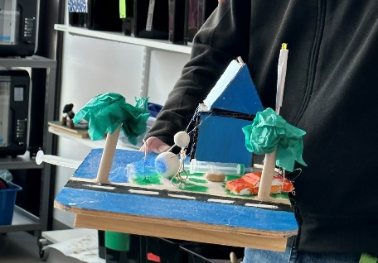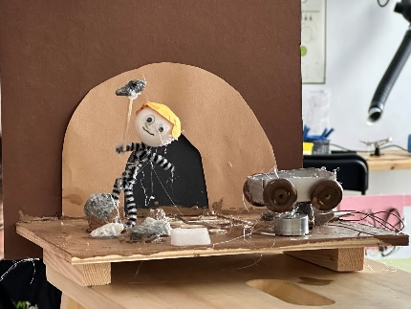

Well, we were not going to be making models ourselves during the afternoon, no mechanics or hydraulics for us, but we were treated to some lessons using ‘virtual reality’ headsets.
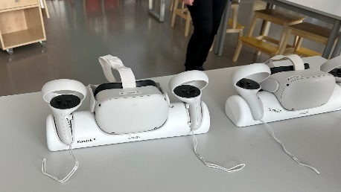
Four of us were given Meta Quest 2 headsets and treated to four different exercises.
None of us are gamers so the handling of two controls was a steep learning curve before we had even started!
So our first task was to draw some lines, possibly using different colours. Next we had to differentiate the width of these and if possible write our name.
We are each standing on our individual spots and we have a virtual reality space around us which is 3 dimensional.
The next and more exacting task was to draw a flower and then colour it in with a tool which created 3d colouring and finally we were required to tilt the completed flower/ plant to change it’s direction.
This was fascinating and very absorbing – it was perhaps sad not to be able to record our efforts. This might be an element that children would find frustrating.
We were shown a video of an artist reproducing a painting whilst wearing a headset and the detail that could be achieved once the large range of graphics tools had been mastered.
Our last exercise was to experience ‘augmented reality’. To achieve this we were still in our own space but now we had introduced a table and we could see outside of our zone. We were required to draw various things on to the table eg flames coming upwards but all the time we could see through to the outside ‘realistic’ space.
This was an excellent experience, one that could be enhancing for pupils. The programme used was ‘Open Brush’ https://openbrush.app/ . It would be interesting to know about the save facilities, especially for children as there could be some frustration when work disappears!

