Lesson observation at Skälbyskolan, Järfälla
We were invited to observe a Grade 6 (12 years old) class – they had worked previously on other modules but today the Chosen theme was : Love and family.
On a screen was the image of Gainsborough’s – ’ The Painter's Daughters with a Cat’
The cat is very faint in this work of art and it predominantly shows the two girls.
The teacher explained that today thay were going to look at this module on Love and Family. The pupils seemed interested from the start, they were sitting in a horseshoe like arrangement at single depth tables.
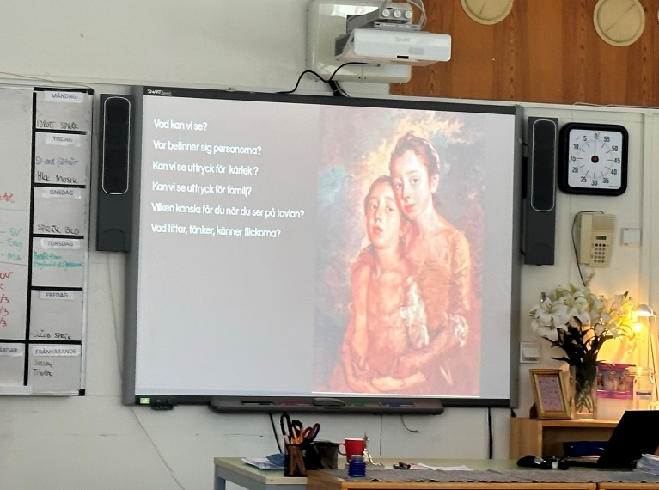
The teacher started by posing the folowing question
What does the word ‘family’ mean to you?
The responses came quite easily and a hands up method was used.
- Closest people to you
- Sometimes struggling
- Live together
- Siblings
- Grown up together
- Can have two fathers or twomother
- Just one mother
- Parents friends are also like family because they are close
All suggestions were acknowledged and received without any further discussion, the pupils showed no inhibition about answers.
The next question posed was:
What does the word ‘love’ mean to you?
There are different types of love – parents, siblings, friends or for a car!
Even though the picture has been on the screen the whole time it is only now that reference is made to it and the title and artist are acknowledged.
A different set of questions are asked.
What can you see?
Where are they?
Expressions?
Expressions of family?
Is the cat a member of the family?
There were some interesting responses to these questions. A few children appeared not to be engaged for example Boy A who was satnear to us didn’t once offer any thoughts.
Responses included
- Painting not finished
- Can we see the cat – painting not finished?
- The picture is old – we can see that by the dresses

The teacher asked them to pretend to be one of the girls – what are you thinking about?
- Sitting very still because father is the artist
- We are bored!
- Perhaps they have lost the cat and are quite sad

The younger daughters are now introduced (same artist) ‘The Painter’s Daughters Chasing a Butterfly’ – again they were asked to consider what they were thinking about. This emotional response was purposeful to evoke a thinking process that would be useful later in the lesson.
Resonses included:
- They are curious about something
- Focussing on the butterfly
- They are holding hands, that’s a sign of love
- There’s a butterfly so it must be spring

The teacher then asked- In society are they rich or poor?
- Rich – because of the dresses
- The cloth of the dresses

A new picture is introduced: ‘Grandma’s favourite’ by Georgios Iakovidis
Responses were saught
- Grandmother holding the child, caring for the child / sign of love
- Cosy – they are sitting inside
- They are close together
- Child is curious – looking at her plate - apples

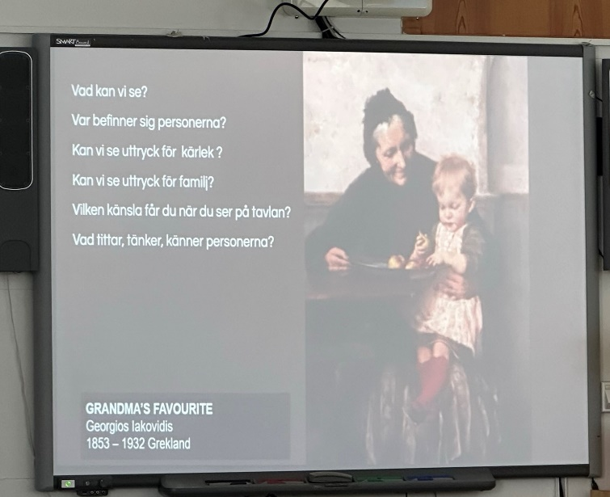
Which picture do you like most and why?
- Warmth between the Grandma and child

They were now asked to choose to be one of the characters from the three paintings and write a diary from the point of view of the character.
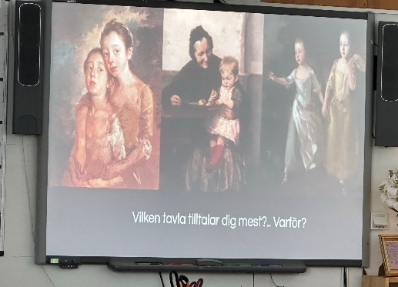
They were also asked a supplementary question
What can you see that we can’t see?
Their work was carried out on iPads – everyone has one, which belongs to the school but they can keep them through their time at school.
It was interesting that there were no male characters in the images but this did not deter the boys from writing. For many it reminded them of their own Grandmother and the comfort given.
Boy A who had not appeared to engage at all throughout the lesson had obviously absorbed considerably more than was outwardly apparent and wrote quite freely once given this task.
We were able to gain a few comments from the children once they started to write.
- Two girls said that they had chosen the first Sisters picture because they both had sisters ... and both had cats. They could empathise. One of them said that the picture might have been painted after they had had an argument, because that's what sisters do - "Disagree. Make peace. Disagree again"!

- Two boys who had chosen the Grandma picture. I asked why. The lad playing Grandma replied that he had chosen the role because the woman in the picture had made him think of his own grandmother and how caring she had been when he was younger.

The pupils really engaged well with the activity and we were impressed with how quickly they engaged with the task and were able to discuss it in their groups. This definitely helped that they could converse before they wrote and also that these groups were self- determined. It was also noted that those that needed a quieter more secluded space were able to take themselves into an anti – room to work.

The lesson had been well prepared in that the pupils had access to all the images on their iPad which also helped them to focus.

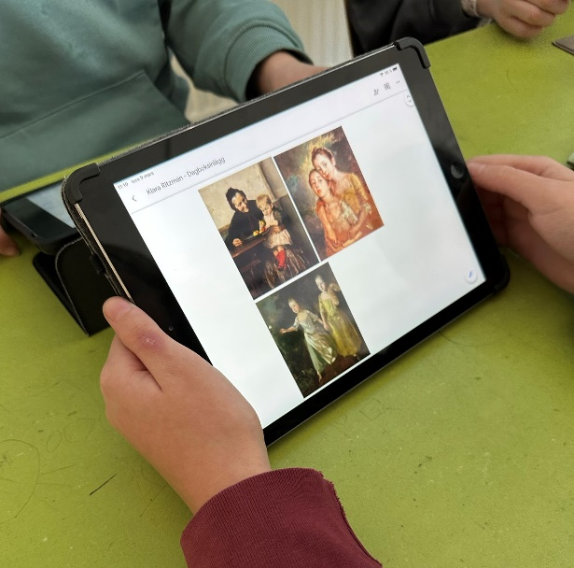
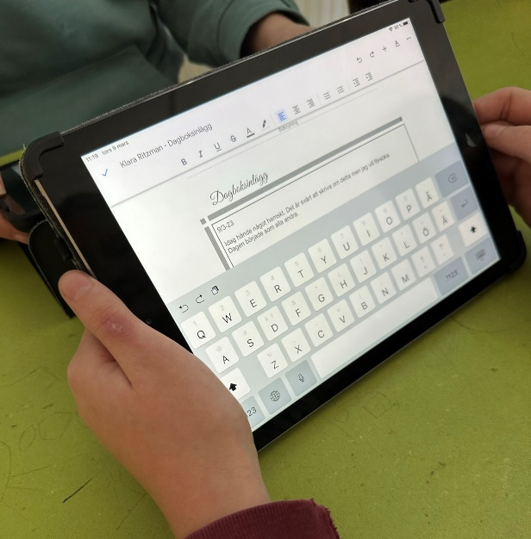

A very enjoyable lesson to observe, it would have been really good to have read the final diary entries.

